1. Java Dequeue :
#CODE:
import java.util.*;

public class Main {

public static void main(String[] args) {

Scanner sc = new Scanner(System.in);

int n = sc.nextInt();
int m = sc.nextInt();

int[] nums = new int[n];

for (int i = 0; i < n; i++) {
nums[i] = sc.nextInt();
}

Deque<Integer> deque = new ArrayDeque<>();
HashSet<Integer> set = new HashSet<>();

int maxUnique = 0;

for (int i = 0; i < n; i++) {

deque.addLast(nums[i]);
set.add(nums[i]);

// Window size should be m
if (deque.size() > m) {
int removed = deque.removeFirst();

// Check if removed number still exists in the window
if (!deque.contains(removed)) {
set.remove(removed);
}
}

if (deque.size() == m) {
maxUnique = Math.max(maxUnique, set.size());
}
}

System.out.println(maxUnique);

sc.close();
}
}

OUTPUT:
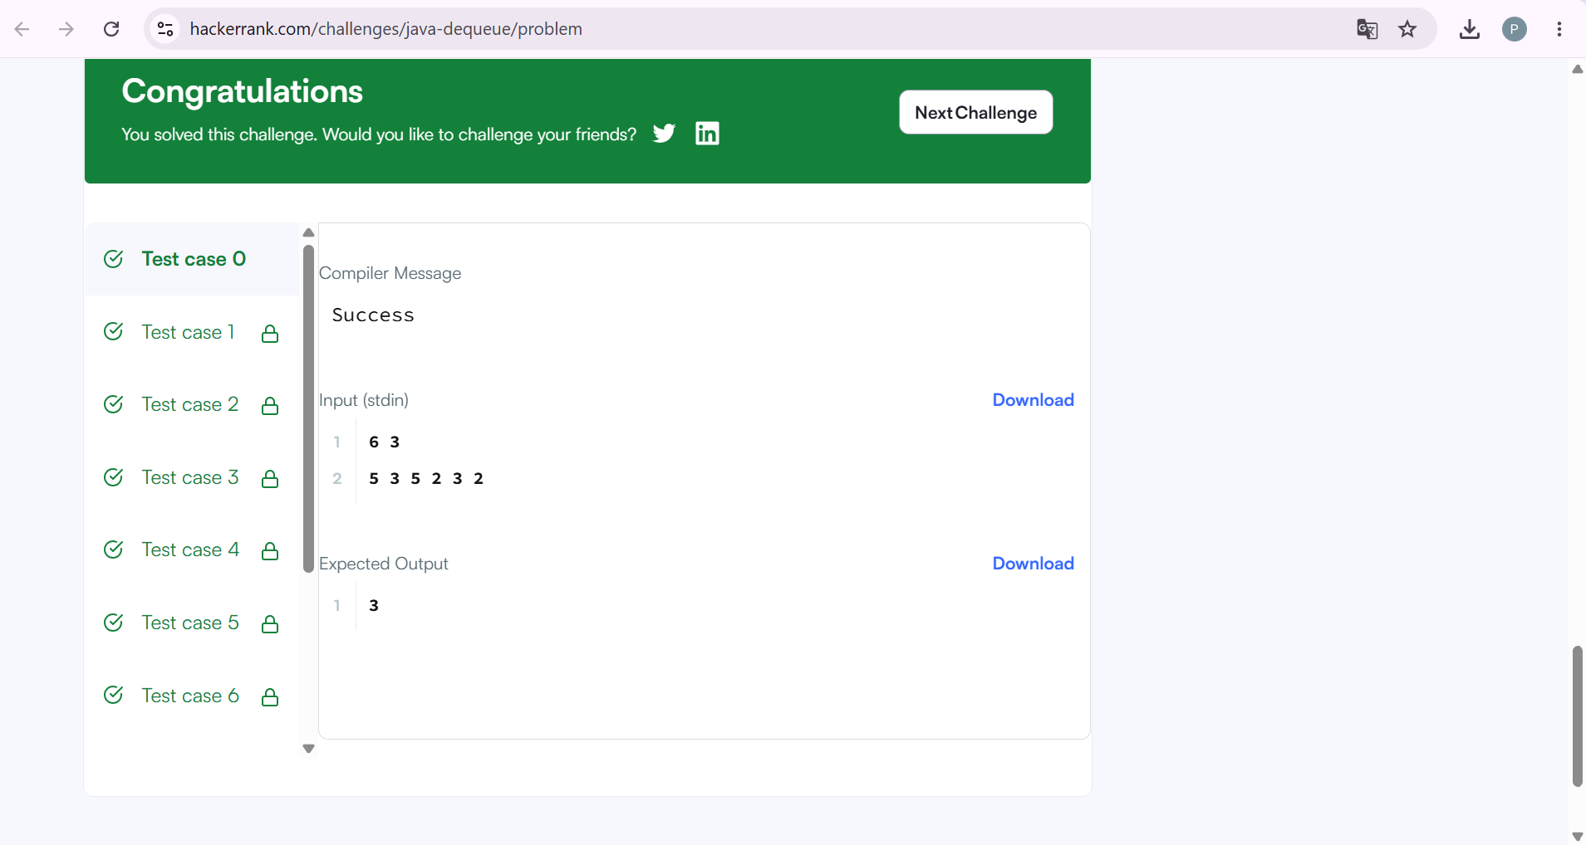

2. Java Hashset :
#CODE:
import java.util.*;

public class Solution {
public static void main(String[] args) {

Scanner sc = new Scanner(System.in);

int n = sc.nextInt();

HashSet<String> set = new HashSet<>();

for (int i = 0; i < n; i++) {

String first = sc.next();
String second = sc.next();

String pair = first + " " + second;

set.add(pair);

System.out.println(set.size());
}

sc.close();
}
}

OUTPUT:
